**BUREAU OF INDIAN STANDARDS**

DRAFT FOR COMMENTS ONLY

(Not to be reproduced without permission of BIS or used as an Indian Standard)

Draft *Indian Standard*

**FIRE RESISTANT GLASS — SPECIFICATION**

*भारतीय मानक मसौदा*

अग्नि प्रतिरोधक काँच **—** विशिष्टि

ICS 81.040.20

Glass, Glassware & Laboratoryware Sectional Committee, CHD 10

**Last date for Comments: ------**

**FOREWORD**

(Formal clauses will be added later)

Fire-resistant glass plays a critical role in ensuring the safety of buildings, occupants, and assets. It is designed to contain fire, smoke, and heat, thereby providing vital escape routes and protection to the building's structural integrity. However, the effectiveness of fire-resistant glass depends on its design, manufacturing, and installation, making it crucial to have standardized procedures in place. Standardization ensures that fire-resistant glass products meet the minimum requirements in terms of fire resistance, optical clarity, impact resistance, and other important properties. It also ensures that the product's performance is consistent across different manufacturers and suppliers, making it easier for architects, builders, and safety regulators to specify, approve, and install fire-resistant glass in buildings. The fire-performance of the glass will only be achieved together with a tested system.

There is no ISO specification available on the subject.

For the purpose of deciding whether a particular requirement of this standard is complied with the final value, observed or calculated, expressing the result of a test or analysis shall be rounded off in accordance with IS 2 : 2022 ‘Rules for rounding off numerical values (*second revision*)’.The number of significant places retained in the rounded off value should be the same as that of the specified value in this standard.

**Draft** Indian Standard

**FIRE RESISTANT GLASS – SPECIFICATION**

**1 SCOPE**

This Standard prescribes the requirements, characteristics, method of sampling and test for fire resistant glass meant for general purposes.

Note: It is limited to the glass unit only and not to the framing or glazing systems.

**2 REFERENCES**

The standards listed below contain provisions which through reference in this text, constitute provisions of this standard. At the time of publication, the editions indicated were valid. All standards are subject to revision and parties to agreements based on this standard are encouraged to investigate the possibility of applying the most recent editions of the standards indicated below:

|  |  |
| --- | --- |
| *IS No.* | *Title* |
| 2553 (Part 1): 2018 | Safety glass – Specification Part 1 Architectural, building and general uses (*fourth revision*) |
| 5437: 2024 (UP) | Rolled glass : Patterned, extra clear patterned, wired and wired-patterned glass – Specification (*second revision*) |
| 5623: 2012 | Glass — Determination of coefficient of mean linear thermal expansion (*second revision*) |
| 16945: 2018 | Fire Resistance Test for Glass Walls |
| 17004: 2018 | Testing methods for processed glass |
| 17346: 2020 | Insulating Glazing Unit — Specification |

**3 TERMINOLOGY**

For the purpose of this standard, the terms and definitions given in IS 17004, IS 2553 (part 1) and IS 16945, in addition to the following shall apply.

**3.1 Element of Building Construction**

A defined construction component, for example, a wall, partition, floor, roof, beam or column.

**3.2 Fire Resistant Glass**

A glass having an ability to perform to its design function upon the application of thermal shock and is capable of satisfying the appropriate fire resistance criteria for a specified period of time. The fire resistant glass shall be classified into three categories based on their fire performance criteria, *see* clause 4.

**3.3 Type Testing**

Determination of the performance of a product (Quality, Fire Resistance), on the basis of either actual tests or other procedures (such as conventional, standardized, tabulated or general accepted values, standardized or recognized calculation methods, test reports when made available, etc.), in accordance with this Standard that demonstrates compliance with this Standard.

**3.4 Insulated Glass**

Fire resistance glass which satisfies the integrity, radiation control and insulation criteria for the anticipated fire resistance duration.

Note: The term “Insulated” when used as an Insulated Glazing Unit (IGU), should not be confused with the term “Insulated” used in this standard for fire resistant glass element.

**3.6 Load Bearing Element**

Element that is intended for use in supporting an external load in a building and maintaining this support in the event of a fire.

**3.7 Test report**

Document that covers the results of tests undertaken on a representative sample of the product from production or on a prototype design of the product

**3.8 Virtual Assembly**

Glazed assembly that is defined by the glass manufacturer for the Type Testing to evaluate the fire resistance characteristics of the glass product.

**4 CLASSIFICATION OF FIRE RESISTANT GLASS**

**4.1 E (T): Fire Resistant Glass with only integrity characteristics**

When exposed to a fire, the glass prevents flames, hot gases, and smoke from penetrating through it to the unexposed side while maintaining its integrity. “T” refers to the time in minutes that the glass maintains its integrity during the fire test as prescribed in 6.2.

**4.2 EW (T): Fire Resistant Glass with the characteristics of Integrity and Radiation control**

When exposed to fire, the glass in addition to meeting the criteria of integrity (E) as specified in 4.1 it should also limit the radiation coming from the specimen to under 15 kW/m2 measured at a distance of 1 meter. “T” refers to the time in minutes that the glass maintains its integrity and radiation control during the fire test as prescribed in 6.3.

**4.3 EI (T): Fire Resistant Glass with the characteristics of Integrity, Radiation Control and Insulation**

When exposed to fire, the glass in addition to meeting the criteria of integrity (E), and radiation control (EW) as specified in 4.1and 4.2 respectively, it should also provide resistance to temperature rise on the unexposed face up to a maximum of 180°C at any single point and average temperature of 140°C. “T” refers to the time in minutes that the glass maintains its integrity and insulation during the fire test as prescribed in 6.4.

**5 FIRE RESISTANT GLASS VARIANTS AND GENERAL REQUIREMENTS**

The commonly available fire resistant glass variants include, but are not limited to, the following:

**5.1 Wired fire resistant glass**

**5.1.1** The type of fire-resistant glass in which a steel wire mesh of thickness dimensions 0.46 mm to 0.56 mm in a square, hexagonal or diamond pattern has been embedded at-least 1 mm inside two sheets of glass panes during the manufacturing process.

**5.1.2** It shall pass the requirements of “wired glass” as specified in IS 5437.

**5.2 Glass-Ceramic fire resistant glass**

**5.2.1** The type of fire-resistant glass produced by a controlled crystallization process by the addition of multiple nucleation agents during the manufacturing process. The glass shall have a mean linear thermal expansion coefficient less than or equal to 2.0× 10−6 K−1 at 20 and 300 °C when tested according to IS 5623. These glasses generally have a very high softening point.

**5.2.2** It shall pass the requirements of thickness, dimensions and squareness as specified in 5.2.1 and 5.2.2 of IS 2553 (Part 1), respectively.

**5.2.3** The allowable defects (spot faults, linear faults, reams, strings, lines, optical faults) shall not exceed the limits specified in 4.4 and 4.5 of IS 14900.

**5.3 Borosilicate fire resistant glass**

**5.3.1** The type of fire-resistant glass produced by combining and melting boric oxide, silica sand, soda ash and alumina, and shall have a very low coefficient of thermal expansion (≤ 4.0 × 10−6 K−1 at 20 and 300 °C) when tested as per IS 5623.

NOTE: The borosilicate based fire resistant glass may additionally have a coating for radiation control.

**5.3.2** It shall also pass the requirements of thickness, dimensions and squareness as specified in 5.2.1 and 5.2.2 of IS 2553 Part 1, respectively.

**5.3.3** The allowable defects (spot faults, linear faults, reams, strings, lines, optical faults) shall not exceed the limits specified in 4.4 and 4.5 of IS 14900.

**5.3.4** In case the borosilicate glass is thermally toughened, it shall pass the fragmentation requirements as specified in 5.2.3 of IS 2553 (Part 1), and in case the borosilicate glass is heat strengthened, it shall pass the fragmentation requirements as specified in 6.1.5 of IS 17004.

NOTE: Borosilicate may or may not be thermally toughened or heat strengthened.

**5.4 Thermally super toughened soda lime silicate fire resistant glass**

**5.4.1** The type of fire-resistant glass produced by majorly combining silicon dioxide, sodium oxide, calcium oxide along with other trace elements and additives, within which a permanent high surface compressive stress has been induced by a controlled heating and cooling process to give it greatly increased resistance to mechanical and thermal stress and prescribed fragmentation characteristics.

**5.4.2** It shall pass the requirements of toughened glass as specified under 5.2 of IS 2553 (Part 1) along with the requirements of allowable defects as specified in 5.1.2 of IS 2553 (Part 1).

**5.4.3** Additionally, when tested for surface compression as per the method prescribed in **6.5** of IS 17004, it shall have surface compression in between 80MPa to 120 MPa.

**5.4.4** Also, when tested for mechanical strength (four point bending test) as per the method prescribed in **6.3** of IS 17004, the mechanical strength shall not be less than 150 MPa.

**5.5 Laminated fire resistant glass**

**5.5.1** The type of fire-resistant glass which is a laminated glass having at least one super toughened glass (conforming to **5.4**) or a borosilicate glass (conforming to **5.3**). It shall pass the requirements of laminated glass as specified under 5.3 of IS 2553 (Part 1) along with the requirements of allowable defects as specified in 5.1.2 of IS 2553 (Part 1).

**5.6 Intumescent interlayer laminated fire resistant glass**

**5.6.1** The type of fire-resistant glass laminated with intumescent interlayer that foams up and gives the required fire-resistance performance. It shall pass the requirements of laminated glass as specified in IS 2553 (Part 1) excluding the requirements of 5.3.3 Light Stability Test, 5.3.4 Bake & Boil Test, 5.3.5 Fracture and Adhesion Test, and 5.3.7 Humidity test.

**5.6.2** *Radiation test*

When tested as per the method specified in **7.3** of IS 17004, there shall not be any sign of delamination between the glass and the interlayer. Disregard all delamination within 15 mm from an original edge or 25 mm from a cut edge.

**5.7** **Gel-filled fire resistant glass**

**5.7.1** Two or more panes of glass separated by spacer and filled with intumescent gel and cured. It shall the pass the requirements of insulated glazing unit as specified under clause **5** of IS 17346 excluding the requirement of climate test (**5.2.2** of IS 17346), dew/ frost point measurement (**5.2.1** of IS 17346), and inert gas level test (**5.2.3** of IS 17346).

**5.7.2** *Radiation test*

When tested as per the method specified in **7.3** of IS 17004, there shall not be any sign of delamination between the glass and the interlayer. Disregard all delamination within 15 mm from an original edge or 25 mm from a cut edge.

**5.8 Low-e coated fire resistant glass**

**5.8.1** The type of fire resistant glass which is majorly based on super toughened-soda-lime-silicate glass or a borosilicate glass, covered with a low-emissivity coating providing the required fire-resistance performance to the system.

**5.8.2** It shall pass the requirements of super toughened glass as specified in **5.4** if it is based on super toughened-soda-lime-silicate glass, and it shall pass the requirements specified in **5.3** if it is based on borosilicate glass.

Note: All the variants are further subjected to the fire performance characteristics test as specified in clause 6 to be called as a fire resistant glass.

**6 FIRE RESISTANCE PERFORMANCE CHARACTERISTICS**

The Fire resistance performance tests will be conducted only when the general requirements specified in clause 5 for the respective glass type are satisfied.

The fire performance tests (6.2, 6.3, & 6.4) shall be carried out using the assembly and support system as specified in Annex A.

**6.1** **Load bearing capacity (R)**

This is the time lapsed in minutes, for which the test specimen continues to maintain its ability to support the test load during the test. Support of the test load is determined by both the amount and the rate of deflection calculated from the measurements taken in **10.4.3.1** of IS 16945. The rate of deflection criteria is not applied till a deflection of L/10 has been exceeded since relatively rapid deflection can occur until stable conditions are reached.

a) For flexural loaded elements:

Limiting deflection D = L2/400d mm; and

Limiting rate of deflection, dD/dt = L2/9000 d mm/min.

where,

L = clear span of the test specimen, in mm; and

d = distance from extreme fibre of the cold design compression zone to the extreme fibre of the cold design tension zone of the structural section, in mm.

b) For vertically loaded elements:

Limiting vertical contraction (negative elongation), C = h/100 mm; and

Limiting rate of vertical contraction (negative elongation), dC/dt = 3h/1000 mm/min

where,

h = initial height, in mm.

**6.2** **Integrity (E)**

These are the times in completed minutes for which the test specimen continues to maintain its separating function during the test carried out as per IS 16945 without either:

a) Permitting the penetration of a gap gauge as specified in **10.4.4.2** of IS 16945; or

b) Resulting in sustained flaming (*see* **3.39** of IS 16945).

The integrity value is determined by whichever of criteria (a, b) fails first.

**6.3** **Radiation (W)**

**6.3.1** These are the times in completed minutes for which the total radiation value as measured by the radiometer is less than 15 kW/m2 at a distance of 1 meter using the test procedure given in **10.4.6** of IS 16945.

**6.3.2** Failure of integrity criteria (*see* 6.2) means automatically failure of the radiation criterion.

**6.4 Insulation (I):**

**6.4.1** This is the time in completed minutes for which the test specimen continues to maintain its separating function during the test prescribed in IS 16945 without developing temperatures on the unexposed surface which either:

a) Increase the average temperature above the initial average temperature, by more than 140°C; and

b) Increase at any location (including the roving thermocouple) above the initial temperature, by more than 180°C.

NOTE:The initial average temperature shall be the average unexposed surface temperature at the commencement of the test.

**6.4.2** If a specimen is tested for insulation (EI), the integrity value is determined by whichever of the three criteria (a, b and c) fails first.

a) Causing the ignition of a cotton pad applied in accordance with **10.4.4.1** of IS 16945;

b) Permitting the penetration of a gap gauge as specified in **10.4.4.2** of IS 16945; or

c) Resulting in sustained flaming.

Note: Failure of integrity criteria (6.4.2) means automatically failure of the insulation criterion.

**6.5 Fire resistance ability (T):** Ability of the Glass to provide fire resistance integrity, radiation control, and insulation or a combination of these ratings against ignition, charring and other damage for a specified period of time. The fire resistance ability according to the performance of Glass shall be declared in minutes using one of the periods: 20, 30, 45, 60, 90, 120, 180, 240 or 360.

Note: Not all periods apply to all fire resistance glass types and vary according to the classification of fire resistance performance.

**7 SAMPLING AND CRITERIA FOR CONFORMITY**

Representative Samples of the material shall be drawn as prescribed in Annex B.

**8 PACKING**

Fire Resistance Glass shall be packed as agreed to between the manufacturer and the purchaser.

Each packet shall be marked with the following information;

a) Indication of source of manufacturer;

b) Nominal thickness of glass;

c) Code or batch number;

d) Month and year of manufacture; and

e) Type of fire resistant glass (*see* clause 5).

**9 MARKING**

**9.1** Each piece of fire resistance glass shall be marked indelibly and distinctly with the following information;

1. In the case of fire resistance glass with Integrity, it shall be marked with the word “E (T)”
2. In the case of fire resistance glass with Integrity and Radiation Control, it shall be marked with the word “EW (T)”.
3. In the case of fire resistance glass with integrity, radiation control and insulation, it shall be marked with the word “EI (T)”.
4. Fire resistance glass may also be marked with any combination of a), b), & c) like “E (T) / EW (T) / EI (T)”.
5. In case, the glass is also used as load bearing element, it shall be marked with “R (T)”, in addition to the above markings.
6. Indication of the source and year of manufacture.
7. In addition to the above markings, the manufacturer may also put a QR code to provide additional information on the fire resistant glass.

**9.2 BIS *Certification Marking***

Each Fire Resistance Glass may also be marked with the standard mark. The use of the Standard Mark is governed by the provisions of The Bureau of Indian Standards Act, 2016 and the Rules and Regulations made thereunder. The details of the conditions under which the licence for use of the Standard Mark may be granted to manufacture or producers, may be obtained from the Bureau of Indian Standards.

**ANNEX A**

(*Clause* **6**)

**ASSEMBLY AND SUPPORT SYSTEM FOR FIRE PERFORMANCE TESTING**

**A-1** Furnace supporting construction shall be as described in fig. 1.

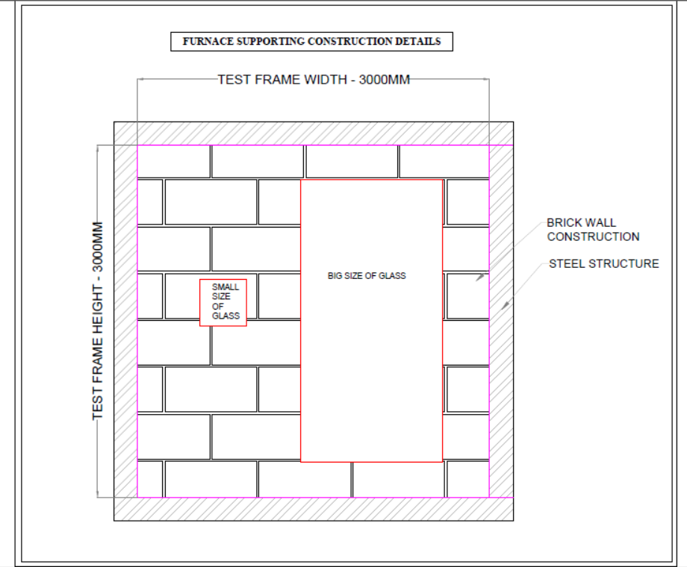

FIG. 1 FURNACE SUPPORTING CONSTRUCTION DETAILS

**A-2** Cross sectional details of assembly structure that holds glass is shown in fig. 2.

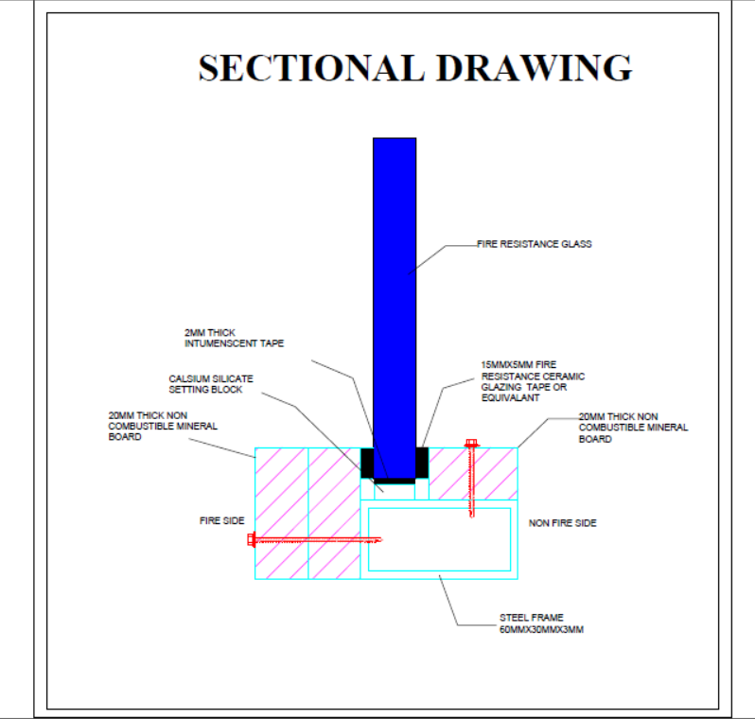

FIG. 2 CROSS SECTIONAL DETAILS OF ASSEMBLY

**ANNEX B**

(*Clause* **7**)

**SAMPLING PLAN AND CRITERIA FOR CONFORMITY**

**B-1 LOT**

For all the fire resistant glasses of the same nominal thickness manufactured using similar type and thickness of interlayer by the same process under similar conditions in a day shall constitute one lot.

**B-2** The conformity of lot to the requirements of standard shall be determined based on the test carried out on samples selected from it.

**B-3** The sampling plan as described in table 1 shall be followed for the various tests to be performed as per the general requirements of FRG variants as mentioned in **5** except for wired fire resistant glass (**5.1**), gel-filled fire resistant glass (**5.7**), and low-e coated fire resistant glass (**5.8**). Tests applicable to different FRG variants are mentioned in table 2.

**B-4** For wired fire resistant glass, and gel-filled fire resistant glass the sampling plan given in IS 5437 and IS 17346 shall be followed, respectively.

**B-5** For low-e coated fire resistant glass, the sampling plan shall be followed as applicable to the base glass.

**B-6** For fire performance characteristics, one sample of each minimum and maximum size and thickness for each fire performance test shall be tested, if either the fire resistance is declared from one side of the glass or if it is fully symmetrical. In case, the fire resistance is declared on both sides of the glass, two samples shall be tested for each fire performance test. In order to ensure the randomness of selection, procedure given in IS 4905 may be followed.

NOTE: FRG rating is valid up to the minimum and maximum size tested.

**B-7** Sizes of the test specimen listed in col 4 of table 1 are recommended in view of the limitation of size of specimen that can be accommodated by the respective test equipment. Test specimen shall be prepared simultaneously along with the product, under similar conditions using similar raw material, that is glass and interlayer as used to manufacture the FRG.

**Table 1 Sample Size and Criteria for Conformity for general requirements of FRG**

(*Clause* B-3, B-7)

|  |  |  |  |  |
| --- | --- | --- | --- | --- |
| **Sl. No.** | **Testing Parameters** | **No. of Samples** | **Size of Samples** | **Acceptance Criteria** |
| (1) | (2) | (3) | (4) | (5) |
|  | Thickness | 5 percent of the quantity from each size, but not less than five safety glasses. | Actual Size of Product | All samples shall pass. In case of any single failure, draw another 5 percent and repeat the test. None of these samples shall fail. |
|  | Dimensions and Squareness | 5 percent of the quantity from each size, but not less than five safety glasses. | Actual Size of Product | All samples shall pass. In case of any single failure, draw another 5 percent and repeat the test. None of these samples shall fail. |
|  | Edge displacement | 5 percent of the quantity from each size, but not less than five safety glasses. | Actual Size of Product | All samples shall pass. In case of any single failure, draw another 5 percent and repeat the test. None of these samples shall fail. |
|  | Flatness | 5 percent of the quantity from each size, but not less than five safety glasses. | Actual Size of Product | All samples shall pass. In case of any single failure, draw another 5 percent and repeat the test. None of these samples shall fail. |
|  | Fragmentation test | **2** | *Min* 0.36 m2 | All samples shall pass. In case of any single failure, draw another 2 samples from the lot and repeat the test. None of these 2 samples shall fail. |
|  | Resistance to shock test | **2** | 610mm × 610mm | All samples shall pass. In case of any single failure, draw another 2 samples from the lot and repeat the test. None of these 2 samples shall fail. |
|  | Resistance to human impact test | **2** | 1938mm × 876mm | All samples shall pass. In case of any single failure, draw another 2 samples from the lot and repeat the test. None of these 2 samples shall fail. |
|  | Surface compression test | **2** | 360mm × 1100mm | All samples shall pass. In case of any single failure, draw another 2 samples from the lot and repeat the test. None of these 2 samples shall fail. |
|  | Four point bending test | **2** | 360mm × 1100mm | All samples shall pass. In case of any single failure, draw another 2 samples from the lot and repeat the test. None of these 2 samples shall fail. |
|  | Light stability test | **3** | 300mm × 300mm, *Minimum* | All samples shall pass. In case of any single failure, draw another 3 samples from the lot and repeat the test. None of these 3 samples shall fail. |
|  | Bake test | **3** | 300mm × 300mm | All samples shall pass. In case of any single failure, draw another 3 samples from the lot and repeat the test. None of these 3 samples shall fail. |
|  | Boil test | **3** | 300mm × 300mm | All samples shall pass. In case of any single failure, draw another 3 samples from the lot and repeat the test. None of these 3 samples shall fail. |
|  | Fracture and adhesion test | **3** | 500mm × 500mm or 300mm × 300mm, as applicable | All samples shall pass. In case of any single failure, draw another 3 samples from the lot and repeat the test. None of these 3 samples shall fail. |
|  | Defects in the central area | **3** | Actual size of product | All samples shall pass. In case of any single failure, draw another 3 samples from the lot and repeat the test. None of these 3 samples shall fail. |
|  | Humidity test | **3** | 300mm × 300mm (The test may be carried out either with or without condensation, as applicable) | All three samples shall pass. In case of any single failure, draw another 3 samples from the lot and repeat the test. None of these 3 samples shall fail. |
|  | Mean linear thermal expansion | **2** | A rod having square cross-section of 10mm × 10mm and length of 50 mm | If the results for the two test specimens differ by not more than 0.2 x 10-6 K-1, take the arithmetic mean. If the difference is larger, repeat the test with 2 other test specimens. |
|  | Radiation test | **3** | 300mm × 300mm | All samples shall pass. In case of any single failure, draw another 3 samples from the lot and repeat the test. None of these 3 samples shall fail. |

**Table 2 Applicable tests for different FRG variants**

(*Clause* B-3)

|  |  |  |  |  |  |  |
| --- | --- | --- | --- | --- | --- | --- |
| **Sl. No.** | **Testing Parameters** | **Glass-Ceramic** | **Borosilicate** | **Thermally super toughened soda lime silicate** | **Laminated** | **Intumescent layer** |
| (1) | (2) | (3) | (4) | (5) | (6) | (7) |
|  | Thickness | Y | Y | Y | Y | Y |
|  | Dimensions and Squareness | Y | Y | Y | Y | Y |
|  | Edge displacement | - | - | - | Y | Y |
|  | Flatness | - | - | Y | - | - |
|  | Fragmentation test | - | As applicable | Y | - | - |
|  | Resistance to shock test | - | - | Y | - | - |
|  | Resistance to human impact test | - | - | Y | Y | Y |
|  | Surface compression test | - | - | Y | - | - |
|  | Four point bending test | - | - | Y | - | - |
|  | Light stability test | - | - | - | Y | - |
|  | Bake test | - | - | - | Y | - |
|  | Boil test | - | - | - | Y | - |
|  | Fracture and adhesion test | - | - | - | Y | - |
|  | Defects in the central area | - | - | - | Y | Y |
|  | Humidity test | - | - | - | - | - |
|  | Mean linear thermal expansion | Y | Y | - | - | - |
|  | Radiation test | - | - | - | - | Y |

**B-8 CRITERIA FOR CONFORMITY**

The acceptance criteria for general requirements of FRG is given at col (5) of table 1. For fire performance characteristics, the fire resistance ability in minutes as applicable in 6.5 shall be reported for the desired fire performance characteristic along with the side of the FRG tested.